- Screen: Nurse
- The today’s duties section in the dashboard – what’s that for? Is it needed?
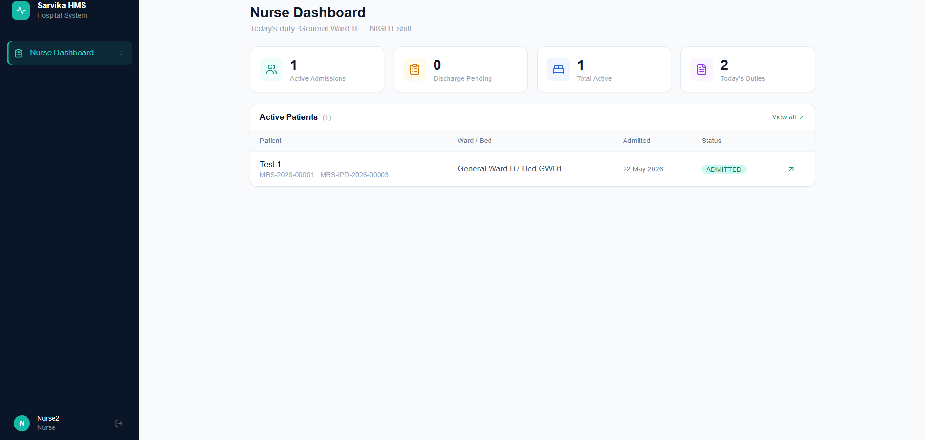
- “Add Charge” button not showing in patient overview and bill for a particular patient. Please note that this “Add Charge” button should not show price – only option to add a bill item (consumable/medicine/procedure/other)
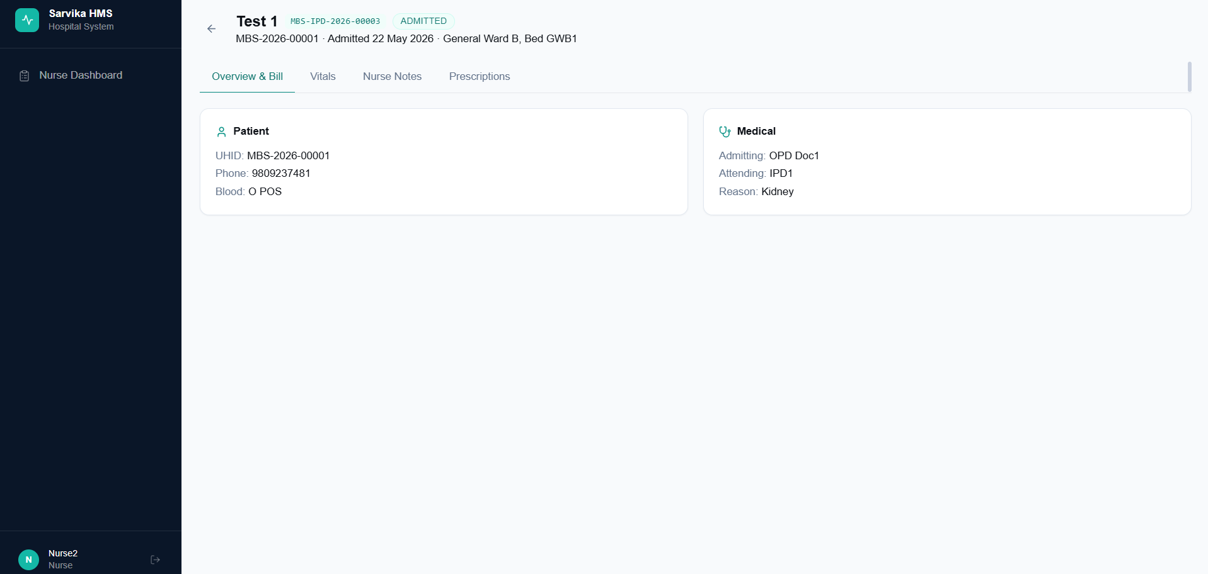
- Vitals and Nurse notes still showing as two different tabs (refer below screenshot) – it should be single section “Vitals and Notes”
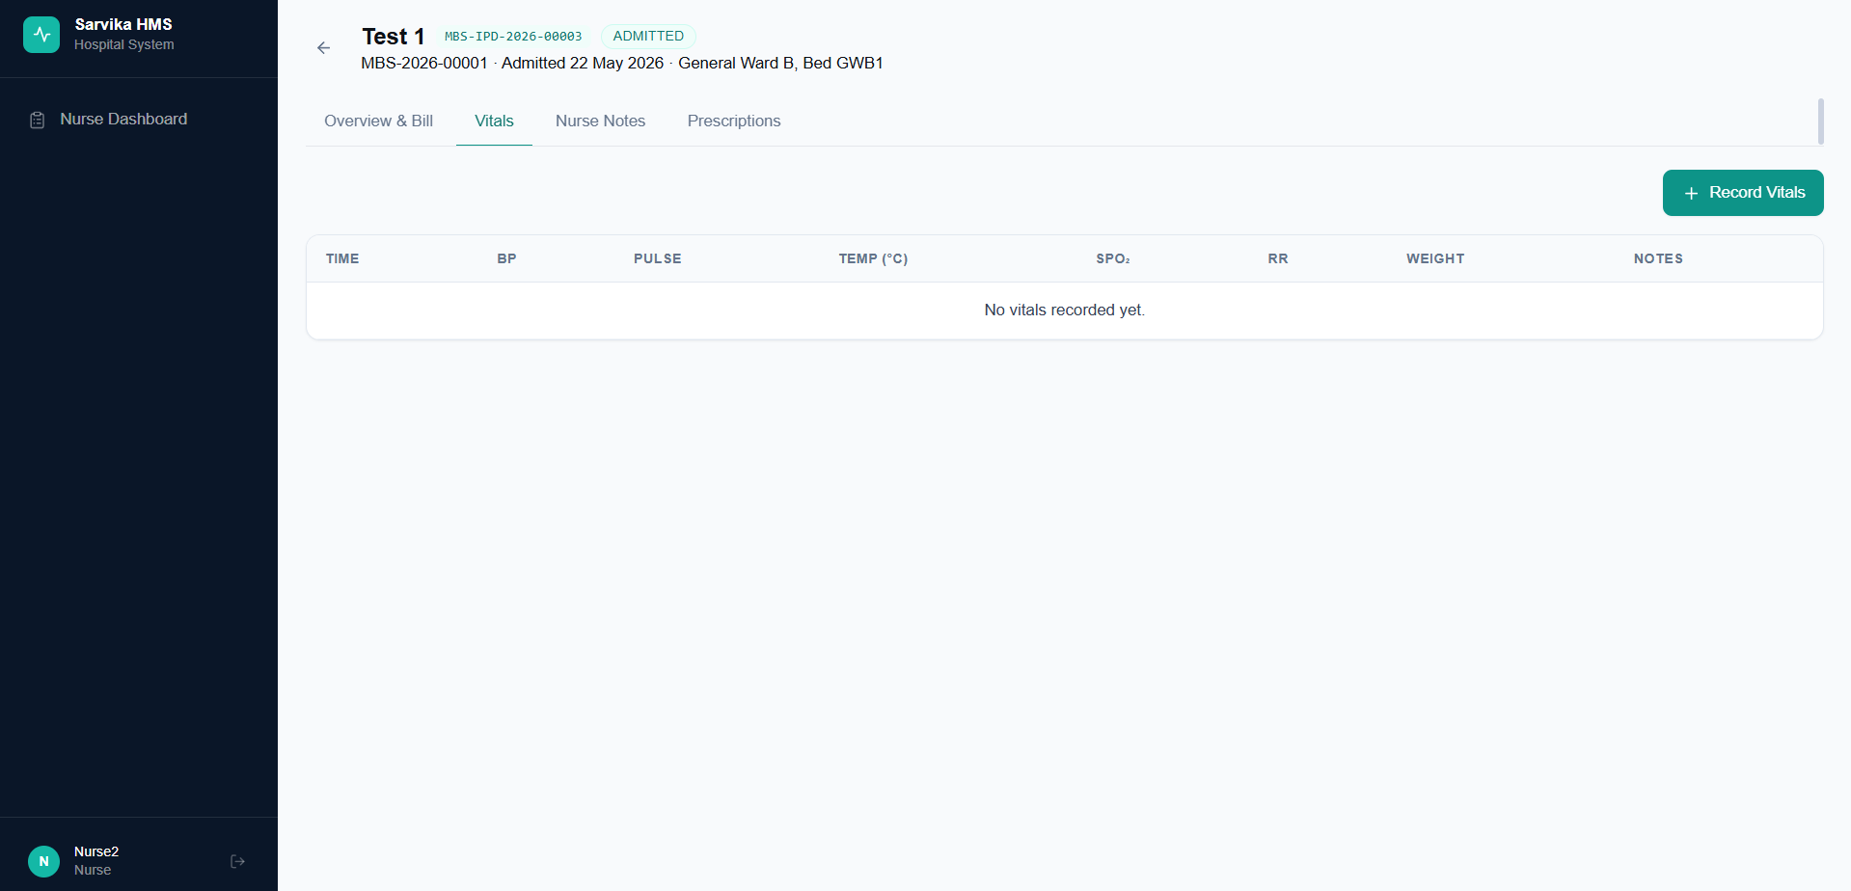
- Nurse should be able to see the prescriptions in the overview tab only – for a patient, please note – this is to be renamed as “Overview” only for ONLY nurse screen (refer below screenshot)
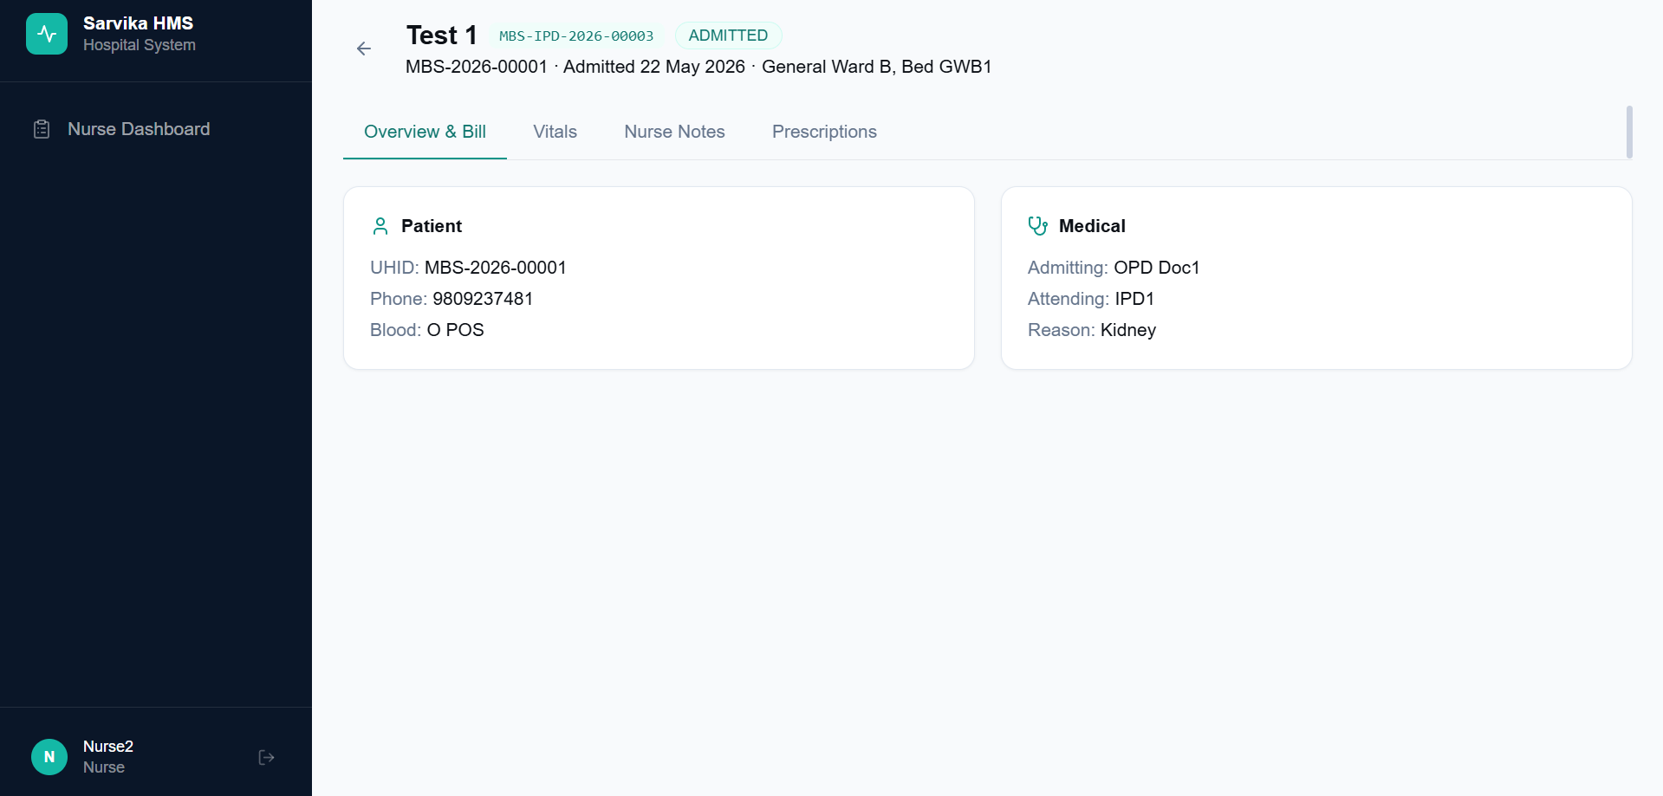
- Nurse should be able to take notes and mark after she has given a medicine as per the prescription to the admitted patient against that prescription
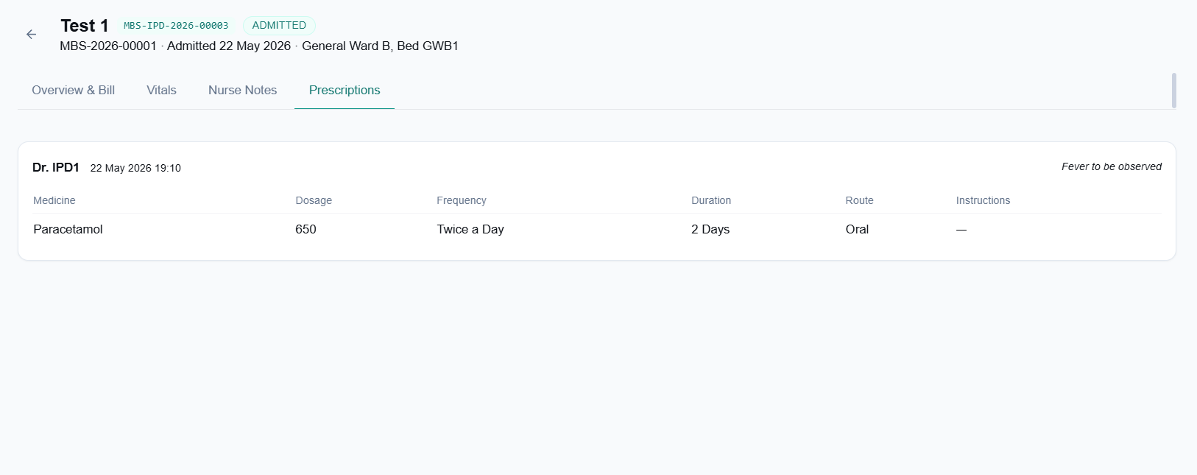

- Screen: Receptionist
- Receptionist can see IPD admissions and can assign a new doctor to any admitted patient in addition to the attending doctor at any point by any doctor’s recommendation (IPD Doctor), though she will not be able to add charge to any ongoing bill. There should be also an option to add “Special Doctor Visit” – wherein the receptionist should be able to type any doctor’s name. (this scenario is for like if a patient needs to be visited by a doctor who is not registered to in the IPD but is making a special visit for this patient’s case)
- In generate bill page – there should be a checkbox option for “Admission Recommended”
- In generate bill page – Initiate IPD admission section will only appear when receptionist checks the “Admission Recommended” option
- In case receptionist selects “No – Emergency Only” in the IPD admission section – the attending doctor box should disappear
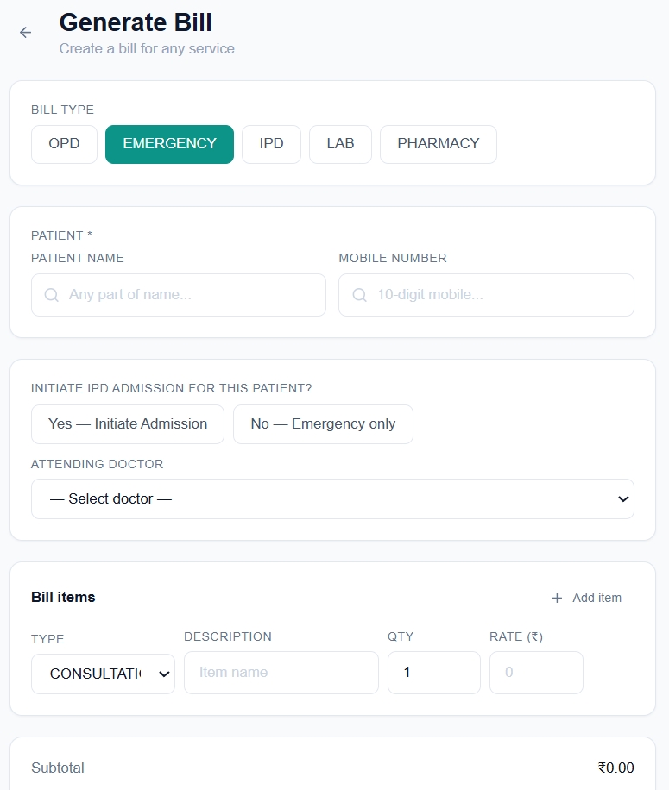
- The attending doctor should be “IPD doctors” only currently it is showing OPD doctors
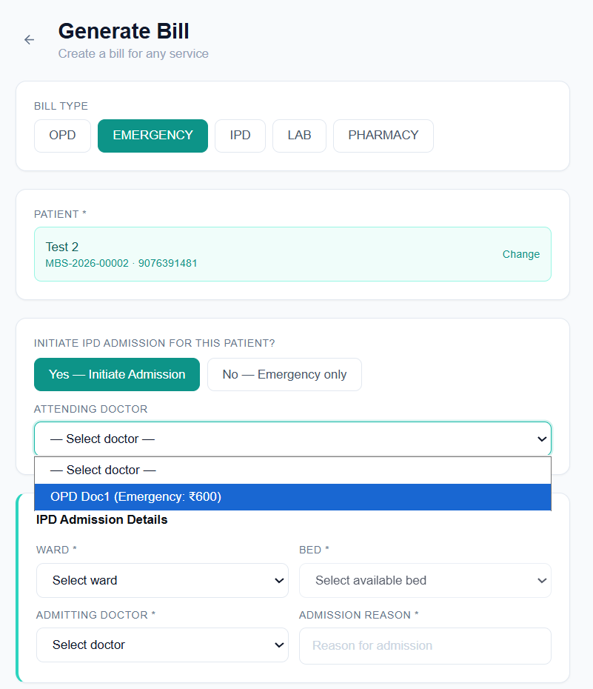
- There should be an “Upload Prescription” button in generate bill page – “Emergency” bill type.
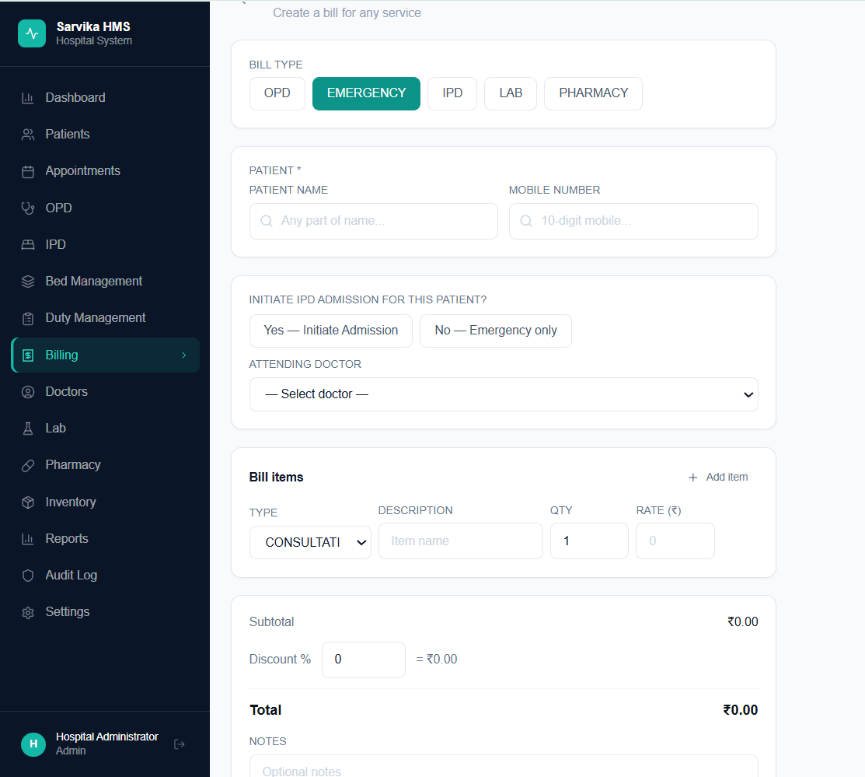

- Screen: Doctor
- Doctor should not be able to see the patient bill summary as well – similar to nurse
- In the overview and Bill page of a patient – the doctor should be able to see and write prescription
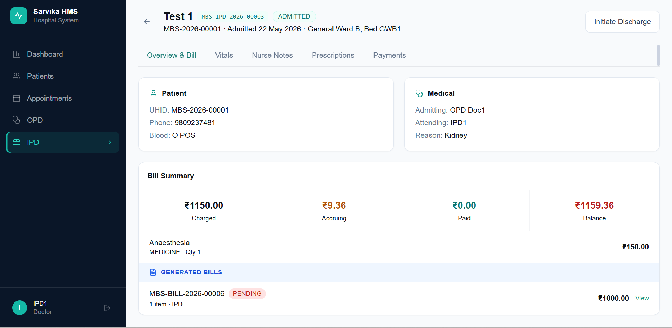
- Doctor should not be able to see the appointments page as well (The doctor can see his today’s appointments in the OPD page anyways – so this is not needed)
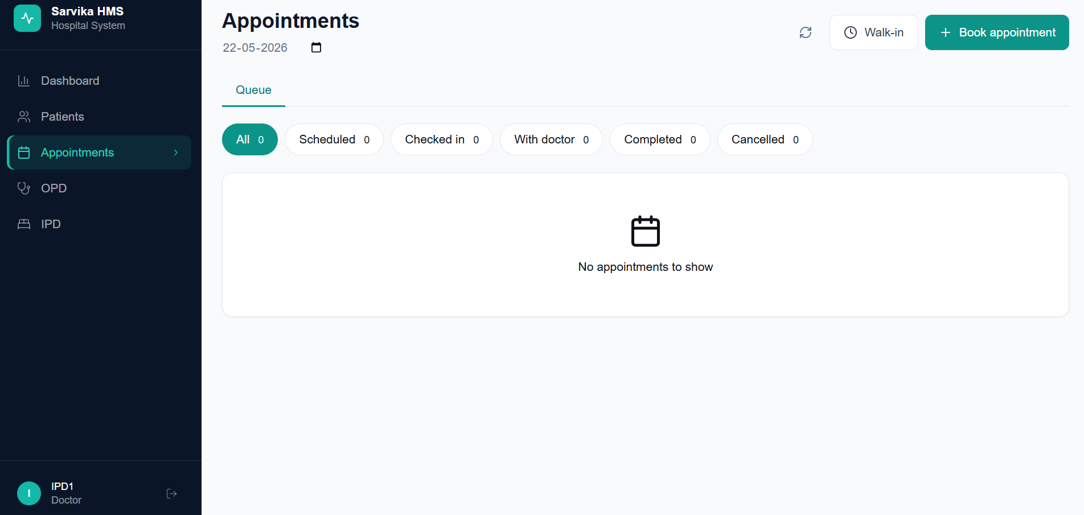
- Doctor should only be able to see his patients in the patients page and not all registered patients with the hospital
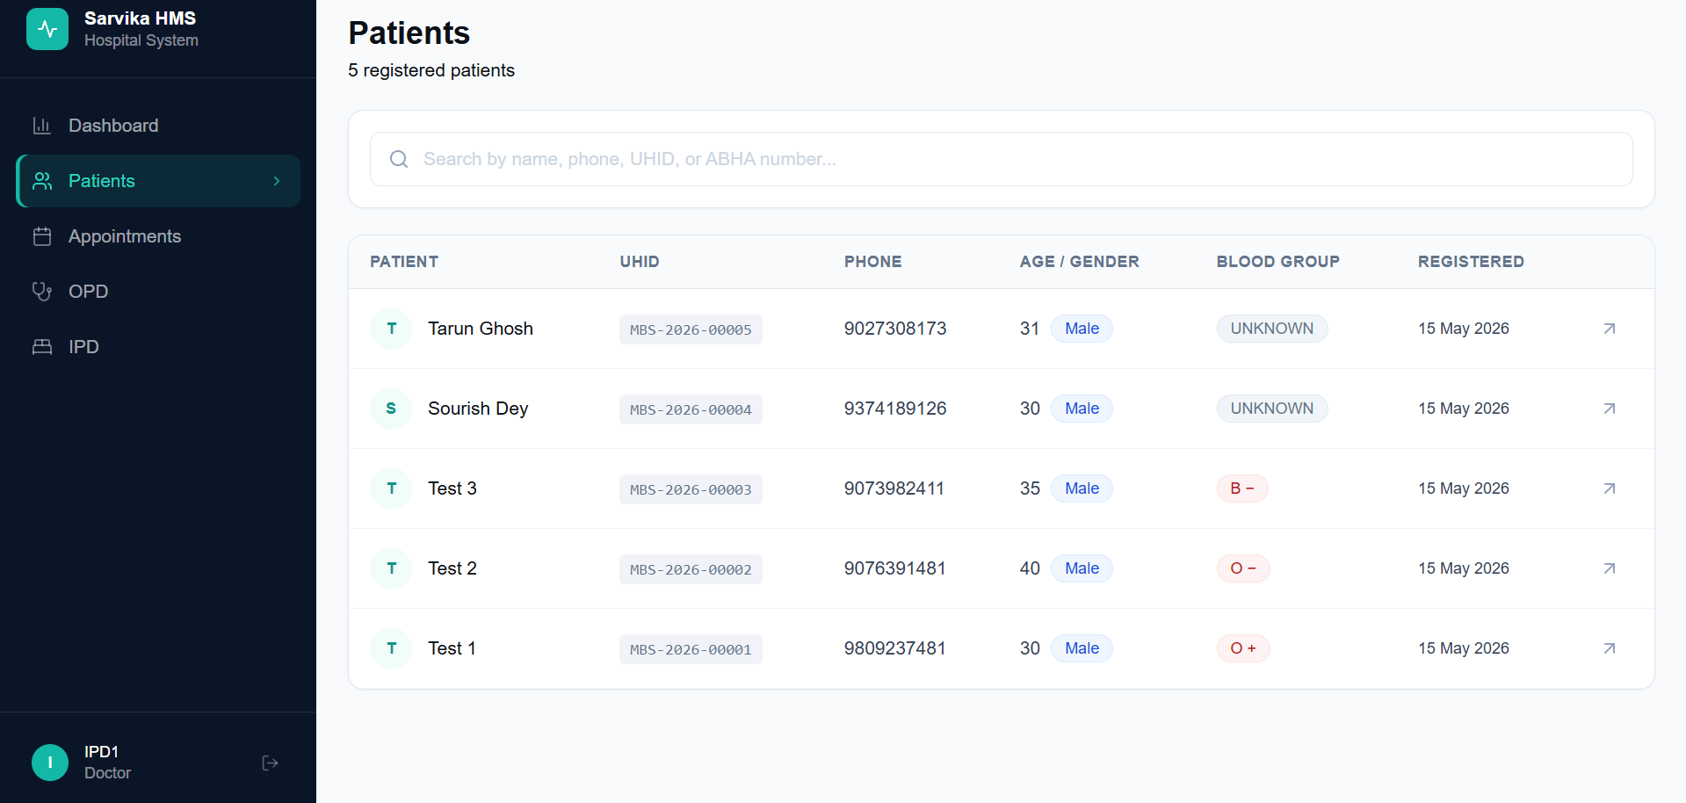
- Doctor dashboard should have data to his relevance – like today’s IPD, OPD and Emergency queue (depending on which departments the doctor is registered)
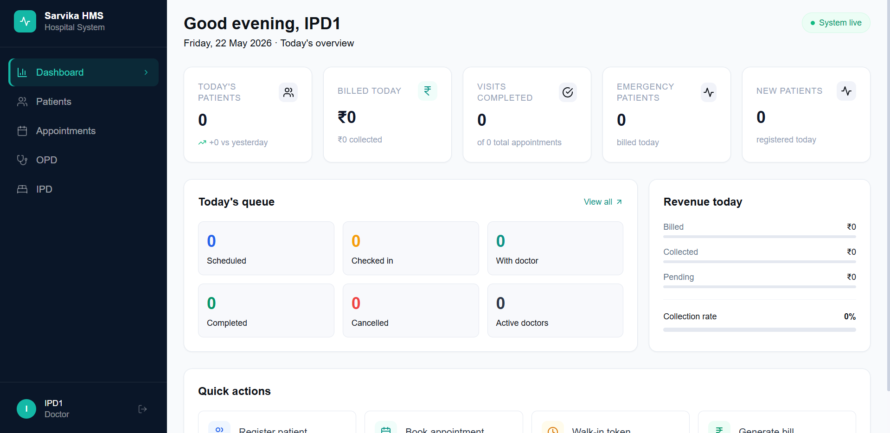
- Doctor should not be able to see the payments tab (refer below screenshot)
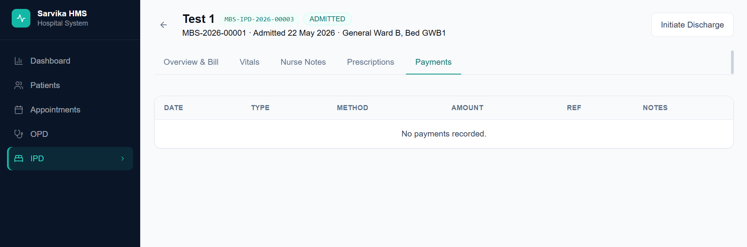

- Screen: Cashier
- In Cashier screen the calculation of the bill is wrong- please refer to the below screenshot – as you see Generated bills is showing Rs. 660 from Emergency (transferred) and also the items from the emergency bill is again shown on top “[From Emergency] Consultation …” which again sums up to 660 and the total bill is hence shown as 1320 (which should actually be 660) only
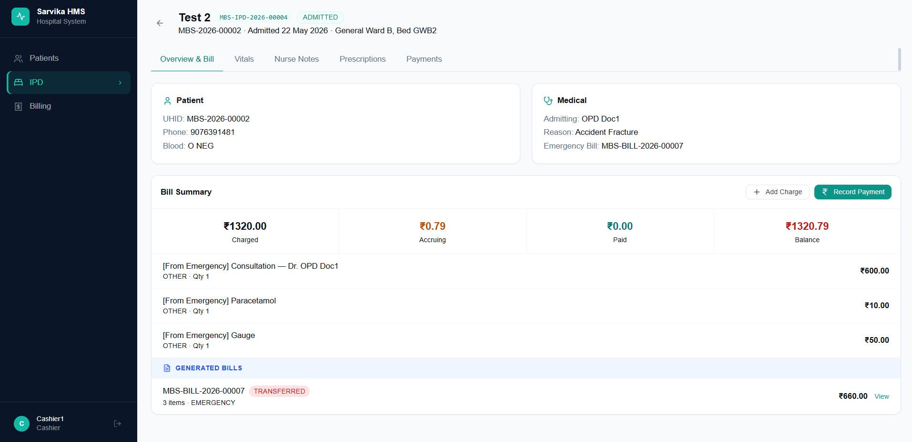
- While collecting payment when Cashier selects payment type as “Insurance” or “TPA” – it should capture the necessary details required (I do not know what necessary details should be taken – please refer to standard billing systems in hospitals and how and what details they register while collecting payments through insurance or TPA)
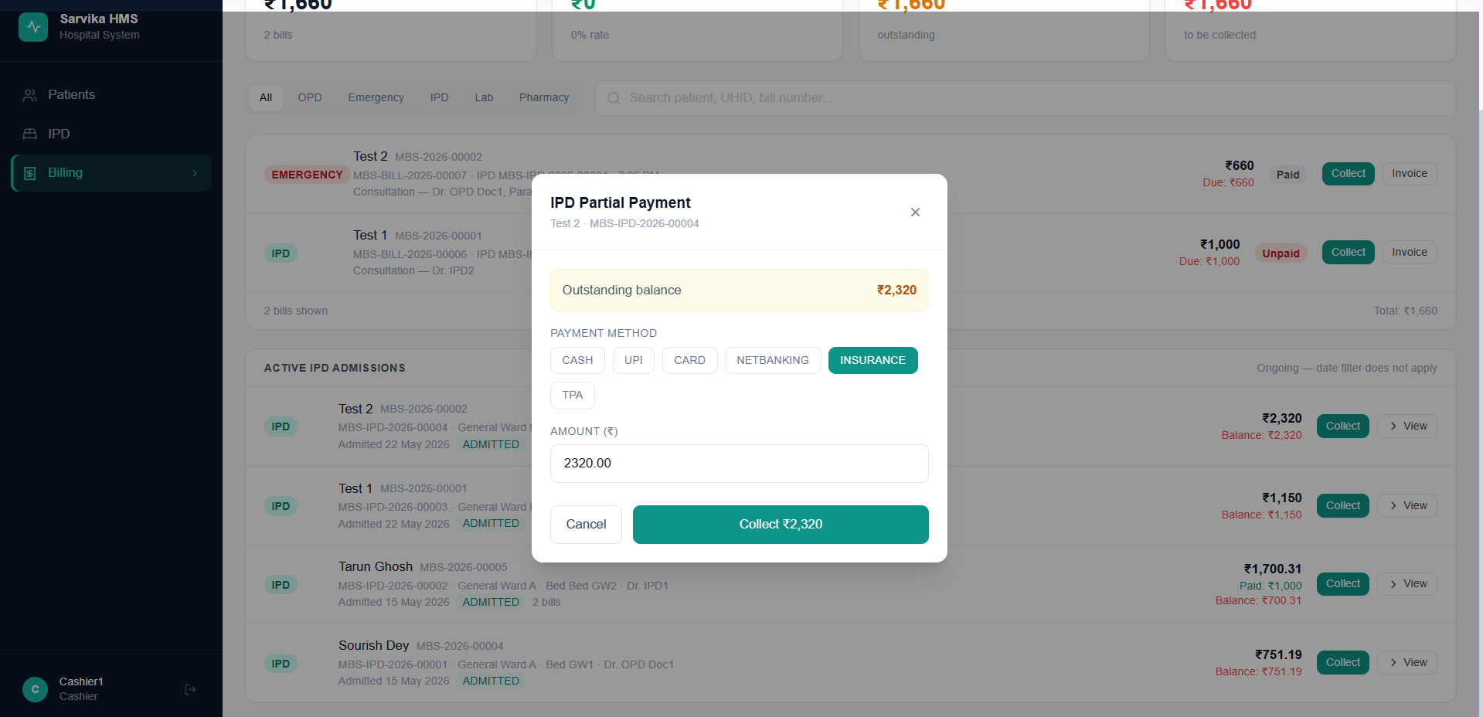
- In the billing page – I understand the bills in the first are today’s bill – we should have a text stating the same “Today’s Bill”
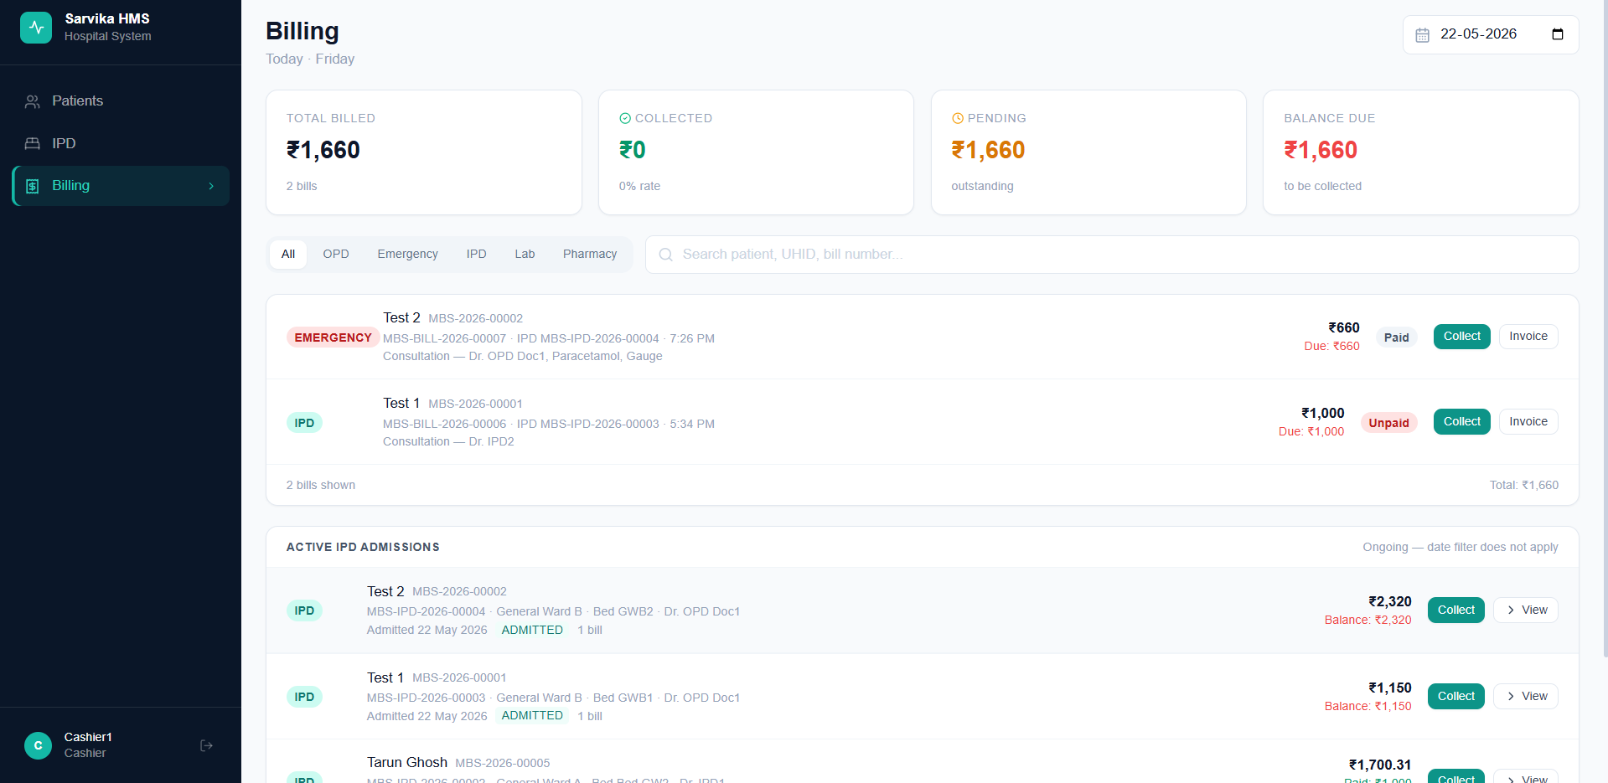

- Other Errors
- Error while saving consumables
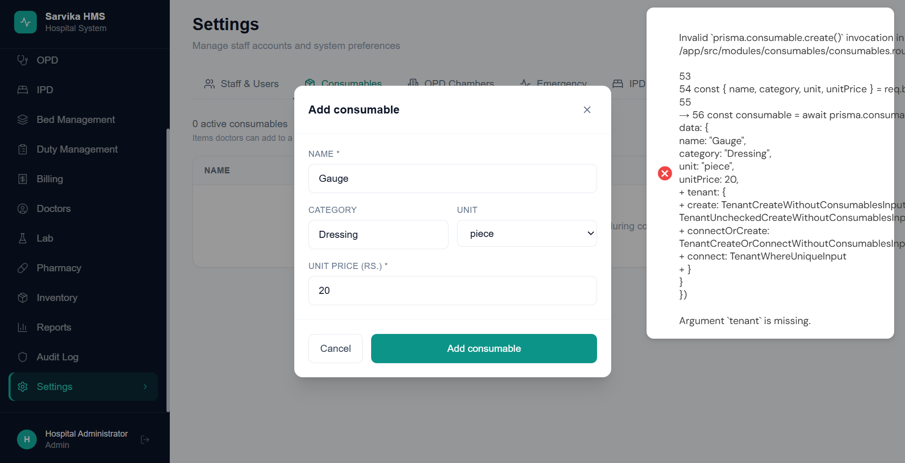
- In billing page for Bill item – “Medicine” should be dropdown as well which will be pre-added by admin like consumables
